Measuring Speed and Velocity
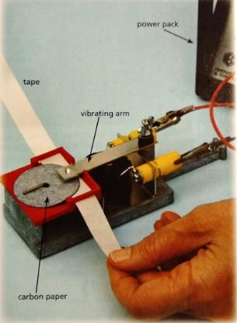
Mostly people measure the speed of an object over a known distance with timing devices like stopwatches. This is what occurs in athletic events and many races. Scientist do the same, but can also use ticker timers in a lab, or video analysis outside the lab. Many student experiments use ticker timers to calculate and analyse speed.
A ticker timer set up
A ticker timer puts a dot on a strip of paper every 0.02 seconds (that’s a rate of 5 dots every 0.1 of a second, or 50 dots a second). If the paper was attached to an object, and that object moved, the distance between the dots tell us how far the paper has moved.
A quick inspection of a ticker timer tape can tell you quite a lot of information about the speed of an object.
fast
constant speed
Slow
constant speed
accelerating
Slow
constant speed
Slow
constant speed

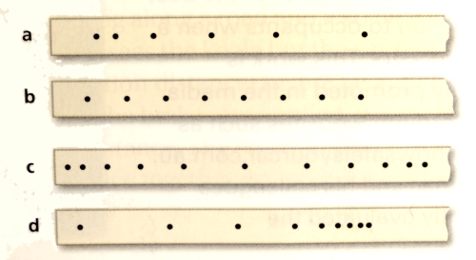
CFU Question 1 – Use the words “constant speed”, “accelerating”, and “decelerating” to describe the motion indicated on each of the tapes below.
a.
b.
c.
d.

CFU Question 2 – the pic below is part of a ticker timer tape. Calculate the speed shown on the tape

